本期内容:
- Receiver启动的方式设想
- Receiver启动源码彻底分析
大家自己做实验的时候一般是一个receiver
多个输入来源，创建多个inputDStream,可以认为Receivers和inputDStream是一一对应的
上节回顾:
上一讲中，我们给大家具体分析了RDD的物理生成和逻辑生成过程，彻底明白Dstream和RDD之间的关系，及其内部其他有关类的具体依赖等信息；
- Dstream是RDD的模板，其内部generatedRDDs保存了每个BatchDuration时间生成的RDD对象实例。Dstream的依赖构成了RDD依赖关系，即从后往前计算时，只要对最后一个Dstream计算即可。
- JobGenerator每隔BatchDuration调用DstreamGraph的generateJobs方法，调用了ForEachDStream的generateJob方法，其内部先调用父Dstream的getOrCompute方法来获取RDD，然后再进行计算，从后往前推，第一个Dstream是ReceiverInputDStream,其compute方法中从receiverTracker中获取对应时间段的metadata信息，然后生成BlockRDD对象，并放入generatedRDDS中
开讲:
由上几节课我们知道
- Spark Streaming的应用程序在处理数据时，会在开始的阶段做好接受数据的准备
- Spark Streaming的应用程序代码定义Dstream时，会定义一个或多个InputDStream,而每个InputDStream则分别对应一个Receiver结合源码的具体类和方法绘制Receiver启动全生命周期主流程图；
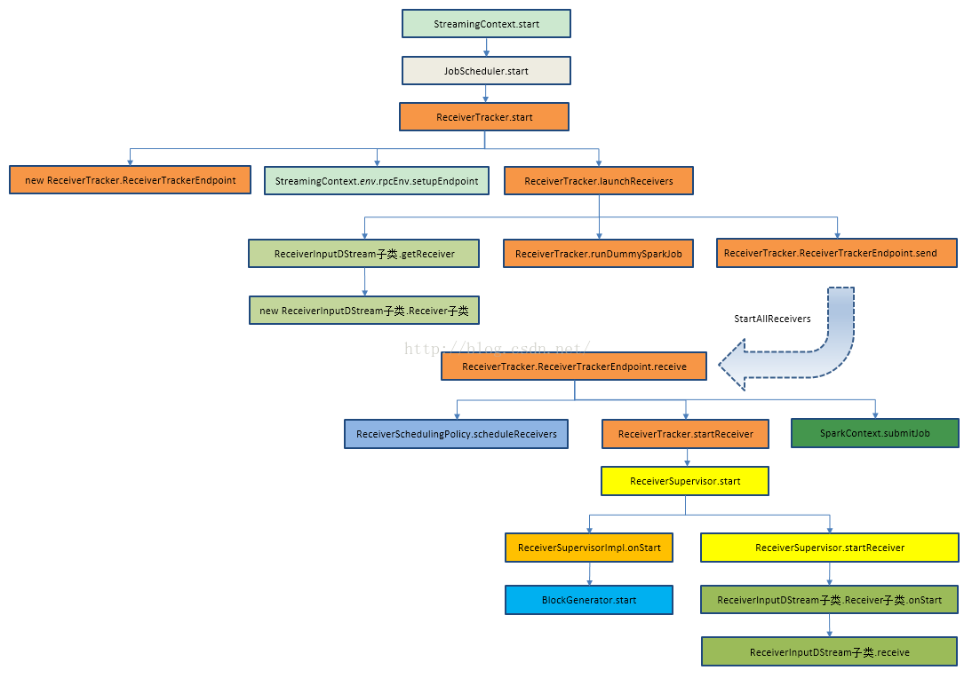
我们就从本讲的内容开始，为大家解析:
那么Receiver启动的方式设想到底是什么了?
Receiver启动的设计问题分析:
- Spark Streaming通过Receiver持续不断的从外部数据源接收数据并把元数据信息汇报给Driver端，由此每个Batch Durations就可以根据汇报的数据生成不同的Job
- 即有可能在同一个Executor之中启动多个Receiver,这种情况之下导致负载不均匀
- 由于Executor运行本身的故障，task有可能启动失败，整个job启动就失败，即receiver启动失败
- Receiver属于Spark Streaming应用程序启动阶段，它又是如何设计，来达到Receiver始终会被启动
- Receivers和InputDStreams又是如何一一对应的，默认情况下一般只有一个Receiver吗
如何启动Receiver?
- 从Spark Core的角度来看，Receiver的启动Spark Core并不知道，Receiver是通过Job的方式启动的，运行在Executor之上的，由task运行
- 一般情况下，只有一个Receiver,但是可以创建不同的数据来源的InputDStream
final private[streaming] class DStreamGraph extends Serializable with Logging {

private val inputStreams = new ArrayBuffer[InputDStream[_]]()
private val outputStreams = new ArrayBuffer[DStream[_]]()
- 启动Receiver的时候，启动一个Job,这个Job里面有RDD的transforamations操作和action的操作，这个Job只有一个partition,这个partition的特殊只有一个成员，这个成员就是启动的Receive
- 这样做的问题
- 如果有多个inputDStrea,那就要启动多个Receiver,每个Receiver也就相当于分片partition,那我们启动Receiver的时候理想的情况下是在不同的机器上启动Receiver,但是Spark Core的角度来看就是应用程序，感觉不到Receiver的特殊性，所以就会按照正常的Job启动的方式来处理，极有可能在一个Executor上启动多个Receiver,这样的话就可能导致负载不均衡。
- 有可能启动Receiver失败，只要集群存在Receiver就不应该失败
- 运行过程中，就默认的而言如果是一个Partition的话，那启动的时候就是一个Task,但是此Task也很可能失败，因此以Task启动的Receiver也会挂掉。
由此，可以得出，对于Receiver失败的话，后果是非常严重的，那么Spark Streaming如何防止这些事的了，下面就寻找Receiver的创建。
这里先给出答案，后面源码会详细分析:
- Spark使用一个job启动一个Receiver,最大程度的保证了负载均衡
- Spark Streaming指定每个Receiver运行在那些Executor上。
- 如果Receiver启动失败，此时并不是Job失败，在内部会重新启动Receiver
- 在StreamingContext的Start方法被调用的时候，JobScheduler的Start方法会被调用。
- /**
* Start the execution of the streams.
*
* @throws IllegalStateException if the StreamingContext is already stopped.
*/
def start(): Unit = synchronized {
state match {
case INITIALIZED =>
startSite.set(DStream.getCreationSite())
StreamingContext.ACTIVATION_LOCK.synchronized {
StreamingContext.assertNoOtherContextIsActive()
try {
validate()
// Start the streaming scheduler in a new thread, so that thread local properties
// like call sites and job groups can be reset without affecting those of the
// current thread.
ThreadUtils.runInNewThread("streaming-start") {
sparkContext.setCallSite(startSite.get)
sparkContext.clearJobGroup()
sparkContext.setLocalProperty(SparkContext.SPARK_JOB_INTERRUPT_ON_CANCEL, "false")
//启动一个子线程，一方面是为了本地初始化工作，另外一方面是不要阻塞主线程
scheduler.start()
}
- 而在JobScheduler的start方法中ReceiverTracker的start方法比调用，Receiver就启动了。
def start(): Unit = synchronized {
if (eventLoop != null) return // scheduler has already been started

logDebug("Starting JobScheduler")
eventLoop = new EventLoop[JobSchedulerEvent]("JobScheduler") {
override protected def onReceive(event: JobSchedulerEvent): Unit = processEvent(event)

override protected def onError(e: Throwable): Unit = reportError("Error in job scheduler", e)
}
eventLoop.start()

// attach rate controllers of input streams to receive batch completion updates
for {
inputDStream <- ssc.graph.getInputStreams
rateController <- inputDStream.rateController
} ssc.addStreamingListener(rateController)

listenerBus.start(ssc.sparkContext)
receiverTracker = new ReceiverTracker(ssc)
inputInfoTracker = new InputInfoTracker(ssc)
//启动receiverTracker
receiverTracker.start()
jobGenerator.start()
logInfo("Started JobScheduler")
}
- ReceiveTracker的start方法启动RPC消息通信体，为啥了?因为receiverTracker会监控整个集群中的Receiver,Receiver转过来要向ReceiverTrackerEnpoint汇报自己的状态，接收的数据，包括生命周期等信息。
- /** Start the endpoint and receiver execution thread. */
def start(): Unit = synchronized {
if (isTrackerStarted) {
throw new SparkException("ReceiverTracker already started")
}
//Receiver的启动时依据输入数据流的
if (!receiverInputStreams.isEmpty) {
endpoint = ssc.env.rpcEnv.setupEndpoint(
"ReceiverTracker", new ReceiverTrackerEndpoint(ssc.env.rpcEnv))
if (!skipReceiverLaunch) launchReceivers()
logInfo("ReceiverTracker started")
trackerState = Started
}
}
- 基于ReceiverInputDStream(是在Driver端)来获得具体的Receivers实例，然后再把他们分到Worker节点上。一个ReceiverInputDStream只产生一个Receiver
- /**
* Get the receivers from the ReceiverInputDStreams, distributes them to the
* worker nodes as a parallel collection, and runs them.
*/
private def launchReceivers(): Unit = {
//一个数据输入来源(receiverInputDStream只产生一个Receiver
val receivers = receiverInputStreams.map(nis => {
val rcvr = nis.getReceiver()
rcvr.setReceiverId(nis.id)
rcvr
})
runDummySparkJob()
logInfo("Starting " + receivers.length + " receivers")
//此时的endpoint就是上面代码中的ReceiverTracker的start方法中构造的ReceiverTrackerEndpoint
endpoint.send(StartAllReceivers(receivers))
}
- ReceiverinputDStream中的getReceiver()方法获得receiver对象后将它发送到worker节点上实例化receiver，然后去接受数据。
- 此方法必须要在子类中实现
/**
* Gets the receiver object that will be sent to the worker nodes
* to receive data. This method needs to defined by any specific implementation
* of a ReceiverInputDStream.
*/def getReceiver(): Receiver[T] //返回的是Receiver对象
启动后台线程调用receive方法
private[streaming]
class SocketReceiver[T: ClassTag]( host: String, port: Int, bytesToObjects: InputStream => Iterator[T], storageLevel: StorageLevel
) extends Receiver[T](storageLevel) with Logging {

def onStart() { // Start the thread that receives data over a connection new Thread("Socket Receiver") { setDaemon(true) override def run() { receive() } }.start()
}

- 其中runDummySparkJob()为了确保所有节点活着，而且避免所有的receivers集中在一个节点上。
/**
* Run the dummy Spark job to ensure that all slaves have registered. This avoids all the
* receivers to be scheduled on the same node.
*
* TODO Should poll the executor number and wait for executors according to
* "spark.scheduler.minRegisteredResourcesRatio" and
* "spark.scheduler.maxRegisteredResourcesWaitingTime" rather than running a dummy job.
*/
private def runDummySparkJob(): Unit = {
if (!ssc.sparkContext.isLocal) {
ssc.sparkContext.makeRDD(1 to 50, 50).map(x => (x, 1)).reduceByKey(_ + _, 20).collect()
}
assert(getExecutors.nonEmpty)
}
- ReceiverInputDStream中的getReceiver()方法获得receiver对象然后将它发送到worker节点上实例化receiver，然后去接受数据。
此方法必须要在子类中实现。
/**
* Gets the receiver object that will be sent to the worker nodes
* to receive data. This method needs to defined by any specific implementation
* of a ReceiverInputDStream.
*/
def getReceiver(): Receiver[T]
- ReceiverTrackerEndpoint源码如下:
- /** RpcEndpoint to receive messages from the receivers. */
private class ReceiverTrackerEndpoint(override val rpcEnv: RpcEnv) extends ThreadSafeRpcEndpoint {
// TODO Remove this thread pool after https://github.com/apache/spark/issues/7385 is merged
private val submitJobThreadPool = ExecutionContext.fromExecutorService(
ThreadUtils.newDaemonCachedThreadPool("submit-job-thread-pool"))
private val walBatchingThreadPool = ExecutionContext.fromExecutorService(
ThreadUtils.newDaemonCachedThreadPool("wal-batching-thread-pool"))
@volatile private var active: Boolean = true
override def receive: PartialFunction[Any, Unit] = {
// Local messages
case StartAllReceivers(receivers) =>
//SchedulingPolicy调度策略
//receivers就是要启动的receiver
//getExecutors获得集群中的Executors的列表
//schedulerReceivers确定receiver可以运行在那个Executor上
val scheduledLocations = schedulingPolicy.scheduleReceivers(receivers, getExecutors)
for (receiver <- receivers) {
//scheduledLoactions根据receiver的ID就找到了当前那些Executors可以运行Receiver
val executors = scheduledLocations(receiver.streamId)
updateReceiverScheduledExecutors(receiver.streamId, executors)
receiverPreferredLocations(receiver.streamId) = receiver.preferredLocation
startReceiver(receiver, executors)
//上述代码之后启动的Receiver确定了，具体Receiver运行在那些Executors上也确定了。
//循环receivers,每次将一个receiver传入过去。
}
//用于接收RestartReceiver消息，从新启动Receiver
case RestartReceiver(receiver) =>
// Old scheduled executors minus the ones that are not active any more
val oldScheduledExecutors = getStoredScheduledExecutors(receiver.streamId)
val scheduledLocations = if (oldScheduledExecutors.nonEmpty) {
// Try global scheduling again
oldScheduledExecutors
} else {
//如果可选的Executor使用完了，则会重新执行rescheduleReceiver重新获取Executor
val oldReceiverInfo = receiverTrackingInfos(receiver.streamId)
// Clear "scheduledLocations" to indicate we are going to do local scheduling
val newReceiverInfo = oldReceiverInfo.copy(
state = ReceiverState.INACTIVE, scheduledLocations = None)
receiverTrackingInfos(receiver.streamId) = newReceiverInfo
schedulingPolicy.rescheduleReceiver(
receiver.streamId,
receiver.preferredLocation,
receiverTrackingInfos,
getExecutors)
}
// Assume there is one receiver restarting at one time, so we don't need to update
// receiverTrackingInfos
//重复调用StartReceiver
startReceiver(receiver, scheduledLocations)
- 从注释中可以看到，Spark Streaming指定receiver在那些Executors运行，而不是基于Spark Core中的Task 来指定的。
Spark使用submit Job的方式启动Receiver,而在应用程序执行的时候会有很多Receiver,这个时候是启动一个Receiver了，还是把所有的Receiver通过这一个Job启动?
在ReceiverTracker的receive方法中startReceiver方法第一个参数就是receiver,从实现的可以看出for循环不断取出receiver,然后调用startReceiver,由此可以得出一个Job只启动一个Receiver
如果Receiver启动失败，此时不会认为是作业失败，会重新发消息给ReceiverTrackerEndpoint重新启动Receiver，这样也就确保了Receivers一定会被启动，这样就不会像Task启动Receiver的话，如果失败受重试次数的影响
/**
* Start a receiver along with its scheduled executors
*/private def startReceiver(
receiver: Receiver[_],// scheduledLocations指定的是在具体的那台物理机器上执行 scheduledLocations: Seq[TaskLocation]): Unit = {
//判断下Receiver的状态是否正常
def shouldStartReceiver: Boolean = {
// It's okay to start when trackerState is Initialized or Started
!(isTrackerStopping || isTrackerStopped)
}
//如果不需要启动Receiver则会调用onReceiverJobFinish()
val receiverId = receiver.streamId//如果不需要启动Receiver则会调用onReceiverJobFinish()
if (!shouldStartReceiver) {
onReceiverJobFinish(receiverId)
return
}

val checkpointDirOption = Option(ssc.checkpointDir)
val serializableHadoopConf =
new SerializableConfiguration(ssc.sparkContext.hadoopConfiguration)
//startReceiverFunc封装了在worker上启动receiver的动作
// Function to start the receiver on the worker node
val startReceiverFunc: Iterator[Receiver[_]] => Unit =
(iterator: Iterator[Receiver[_]]) => {
if (!iterator.hasNext) {
throw new SparkException(
"Could not start receiver as object not found.")
}
if (TaskContext.get().attemptNumber() == 0) {
val receiver = iterator.next()
assert(iterator.hasNext == false)//ReceiverSupervisorImpl是Receiver的监控器，同时负责数据的写等操作
val supervisor = new ReceiverSupervisorImpl(
receiver, SparkEnv.get, serializableHadoopConf.value, checkpointDirOption)
supervisor.start()
supervisor.awaitTermination()
} else {//如果你想重新启动receiver的话，你需要重新完成上面的调度，从新schedule，而不是Task重试。
// It's restarted by TaskScheduler, but we want to reschedule it again. So exit it.
}
}

// Create the RDD using the scheduledLocations to run the receiver in a Spark job
val receiverRDD: RDD[Receiver[_]] =
if (scheduledLocations.isEmpty) {
ssc.sc.makeRDD(Seq(receiver), 1)
} else {
val preferredLocations = scheduledLocations.map(_.toString).distinct
ssc.sc.makeRDD(Seq(receiver -> preferredLocations))
}//receiverID可以看出receiver只有一个
receiverRDD.setName(s"Receiver $receiverId")
ssc.sparkContext.setJobDescription(s"Streaming job running receiver $receiverId")
ssc.sparkContext.setCallSite(Option(ssc.getStartSite()).getOrElse(Utils.getCallSite()))
//每个Receiver的启动都会触发一个Job,而不是一个作业的Task去启动所有的Receiver,应用程序一般会有很多Receiver,调用SparkContext的submitJob,为了启动Receiver,启动了Spark一个作业。
val future = ssc.sparkContext.submitJob[Receiver[_], Unit, Unit](
receiverRDD, startReceiverFunc, Seq(0), (_, _) => Unit, ())
// We will keep restarting the receiver job until ReceiverTracker is stopped
future.onComplete {
case Success(_) =>// shouldStartReceiver默认是true
if (!shouldStartReceiver) {
onReceiverJobFinish(receiverId)
} else {
logInfo(s"Restarting Receiver $receiverId")
self.send(RestartReceiver(receiver))
}

case Failure(e) =>
if (!shouldStartReceiver) {
onReceiverJobFinish(receiverId)
} else {
logError("Receiver has been stopped. Try to restart it.", e)
logInfo(s"Restarting Receiver $receiverId") //RestartReceiver
self.send(RestartReceiver(receiver))
}//使用线程池的方式提交Job，这样的好处是可以并发的启动Receiver。
}(submitJobThreadPool)
logInfo(s"Receiver ${receiver.streamId} started")
}
- 当receiver启动失败的时候，重新启动receiver
/**
* This message will trigger ReceiverTrackerEndpoint to restart a Spark job for the receiver.
*/private[streaming] case class RestartReceiver(receiver: Receiver[_])
extends ReceiverTrackerLocalMessage
- 当Receiver关闭的话，并不需要重新启动Spark Job.
/**
* Call when a receiver is terminated. It means we won't restart its Spark job.
*/private def onReceiverJobFinish(receiverId: Int): Unit = {
receiverJobExitLatch.countDown()//使用foreach将receiver从receiverTrackingInfo中去掉。
receiverTrackingInfos.remove(receiverId).foreach { receiverTrackingInfo =>
if (receiverTrackingInfo.state == ReceiverState.ACTIVE) {
logWarning(s"Receiver $receiverId exited but didn't deregister")
}
}
}
- Supervisor.start()，在子类ReceiverSupervisorImpl中并没有start方法，因此调用的是父类ReceiverSupervisor的start方法
/** Start the supervisor */def start() {
onStart() //具体实现是子类实现的。
startReceiver()
}
其具体实现是在子类的ReceiverSupervivorImpl的onStart方法
override protected def onStart() {
registeredBlockGenerators.foreach { _.start() }
}
此时的start方法调用那个的是BlockGenerator的start方法
/** Start block generating and pushing threads. */
def start(): Unit = synchronized {
if (state == Initialized) {
state = Active
blockIntervalTimer.start()
blockPushingThread.start()
logInfo("Started BlockGenerator")
} else {
throw new SparkException(
s"Cannot start BlockGenerator as its not in the Initialized state [state = $state]")
}
}

